**What is HTTP**

Whenever you decide to check out your friends' pictures on social networks or leave them a message, watch a funny video with kittens, or find the meaning of an unknown term in the search engine, the device (client) from which you surf the Internet sends a request to the server and receives a response from it.

A**client** is a customer of a service, and a **server**is a computer that serves users or other computers. It can be located remotely, tens of thousands of kilometers away from you. The technology in which the network load is distributed between servers and service customers is called **Client-Server Architecture**.

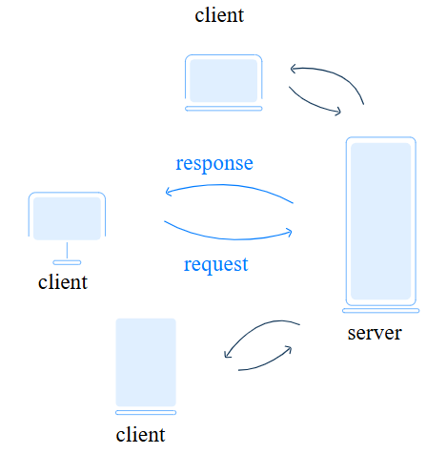

Data exchange between the client and the server takes place due to the **HTTP**. HTTP stands for **HyperText Transfer Protocol**. A**protocol** is a set of rules and conventions that define a uniform way to exchange data between different programs and handle errors. Like a waiter in a restaurant, it accepts your requests, takes them to the server for processing, and then comes back to you with a response.

**Short HTTP History**

HTTP was developed by a scientist and CERN employee *Tim Berners-Lee*, theinventor of the World Wide Web.

Work on the protocol continued for two years, and in March 1991, HTTP was used as a technology to help access documents on the Internet and facilitate hypertext navigation. This was Protocol version 0.9. It was designed to optimize communication(request-response) between the client and the server on the network.

Currently, the most recent version of the Protocol is **HTTP/3.0**, but the most common version is still **HTTP/2.0**, released in 2015. Prior to that, HTTP/1.1 (released in 1999) was used for as long as sixteen years. This standard satisfied everyone for many years because of its innovations: with the advent of HTTP/1.1, the transfer of requests from client to server was greatly accelerated.

Not all sites have switched to HTTP/2 yet, but browsers support both new and old standards.

**What is HTTPS**

Despite the great functionality and popularity of HTTP, there is one drawback: data is transmitted in an unsecured form. This flaw can be critical when it comes to paying for purchases over the Internet or sending passport data: no user wants their confidential information to leak.

To make the Internet space safer, the programmers decided to develop an add-on over HTTP, which helps to avoid data interception by encryption. The HTTP extension is called **HTTPS** and stands for **HyperText Transfer Protocol Secure**.

HTTPS provides a secure connection between the user's browser and the web server. Often, the browser window displays a green address bar or lock indicating encrypted data transfer. You can also check the address bar of your web browser to see if you have a secure connection. It should start with "*https://*".

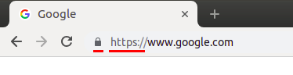

**Conclusion**

This protocol acts as a translator between your device and a server, enabling data exchange. The most common version is HTTP/2.0, though HTTP/1.1 is still in use. You can already apply the basics of HTTP! While browsing the web, notice whether you're using HTTP or HTTPS, the latter being more secure. It encrypts your data during transfer. You'll need to delve deeper into HTTP, if you plan to build apps or websites.

So, let's engage in some practice exercises to reinforce this foundational knowledge!

What is a protocol?

set of rules by which programs or devices communicate with each other, exchange data, and handle errors.

Match the HTTP versions with the years when they were invented.

* **HTTP/0.9** → 1**991**
* **HTTP/1.1** → **1999**
* **HTTP/2.0** → **2015**

**Explanation:**

* **HTTP/0.9** was the very first version, simple and minimal — introduced in **1991**.
* **HTTP/1.1** improved features like persistent connections — became standard around **1999**.
* **HTTP/2.0** brought major performance improvements like multiplexing — released in **2015**.